Research Project- John Shop

Nicholas Jumpp- 1501298

Kimone V. Roper Ist -1403541

University of Technology Jamaica

Table Of Content

S.O.L.I.D. Principles 3

Design Patterns 5

MVC Pattern 5

Model 5

View 5

Controller 5

Repository Pattern 6

Singleton Pattern 6

Factory Pattern 6

References 7

**S.O.L.I.D. Principles**

“Object-Oriented type of programming brought a new design to software development. This enables developers to combine data with the same purpose/functionality in one class to deal with the sole purpose there, regardless of the entire application.” (Nnamdi, 2018).

The five principles are as follows:

* S – Single Responsibility Principle (SRP)
* O – Open Closed Principle (OCP)
* L – Liskov Substitution Principle (LSP)
* I – Interface Segregation Principle (ISP)
* D – Dependency Inversion Principle (DIP)

The Single Responsibility Principle (SRP) states that “A class should have one, and only one job.”(Barber, 2015)

* The SRP is seen in the adminlogin.js file as its only job is to verify a user for successful login. As seen in the screenshot below the check function simply verifies the login of a an admin that being the manager or the delivery person. The credentials function simply acquires the credentials from the textboxes on the login.hml page and return the username and password

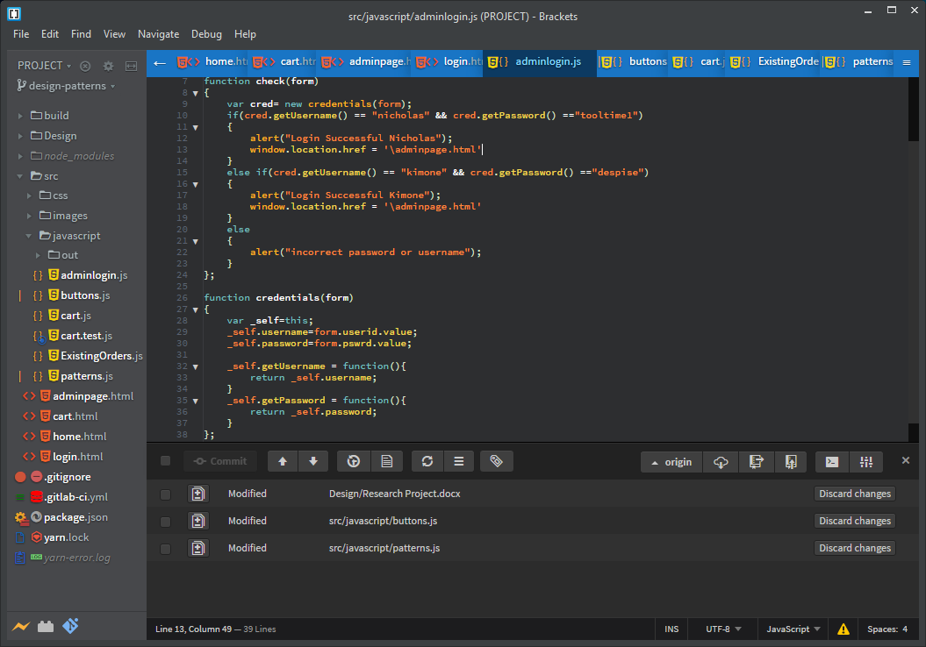

The Open Closed Principle (OCP) states that “You should be able to extend a classes behavior, without modifying.”(Barber, 2015)

* OCP was is seen in the cart.js file as to which for the printCart finction is open to to extensions but closed for modifications. So it is extended and used by other functions that will call it but its base is still the same and is not modified

The Liskov Substitution Principle (LSP) states that “Derived classes must be substitutable for their base classes.”( Barber, 2015)

The Interface Segregation Principle (ISP) states “Make fine grained interfaces that are client specific.”( Barber, 2015)

* ISP was not implemented as to that interfaces are not able to be created due to there is no built in support for traditional abstraction in JavaScript.

The Dependency Inversion Principle (DIP) states “Depend on abstraction, not on concretion.”( Barber, 2015)

* The screenshot below demonstrates dependency inversion in which it is not being dependent on a specific database such as localStorage or MySQL. Simple just to place the database to be used in the parameter and it will run that specific database

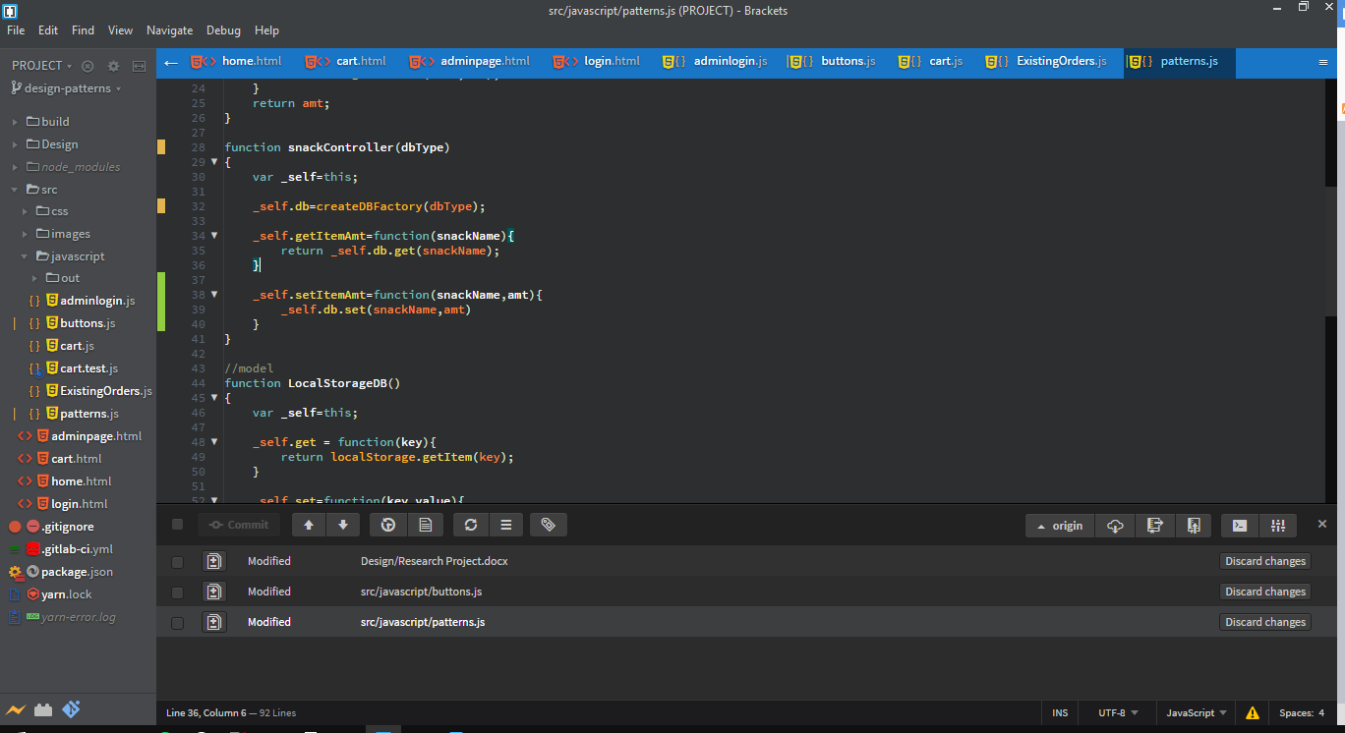

**Design Patterns**

Model View Controller (MVC) Pattern

MVC Pattern stands for Model-View-Controller Pattern. This pattern is used to separate application's concerns. (Tutorialspoint.com)

* Model - Model represents an object carrying data. It can also have logic to update controller if its data changes.
* View - View represents the visualization of the data that model contains.
* Controller - Controller acts on both model and view. It controls the data flow into model object and updates the view whenever data changes. It keeps view and model separate.

Model

The storage medium used in this research project is localStorage that is within modern browsers which stores necessary information from the user to be either presented back to them or to the manager or delivery man.

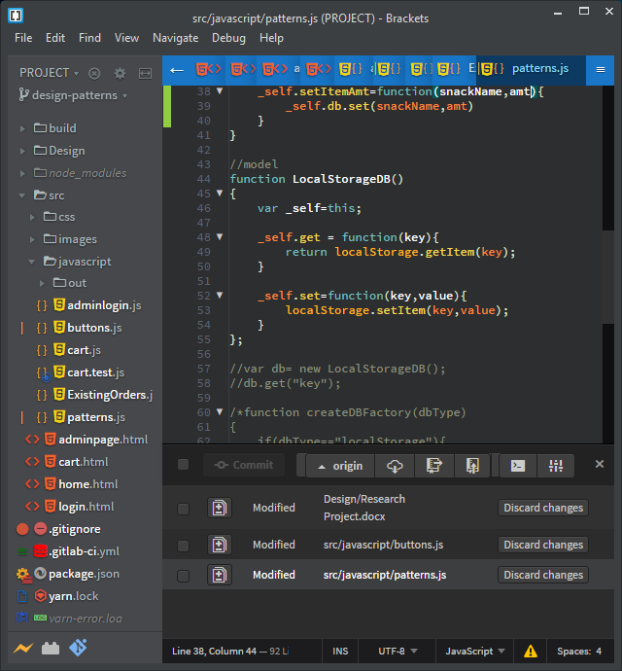

The screenshot above shows the model used which is localStorage to act as our database which contains the two functions to update(_self.set) and retrieve(_self.get).

View

In our research project the view is our UI presented to the customer and manager/ delivery man of John Shop which was coded using HTML & CSS for styling.

Controller

The controller works in conjunction with the model and the view as to update the page as necessary if there has been any changes made from the view portion or from the model portion to the view.



The screenshot above shows a function that is implementing the controller in the MVC pattern for snacks in the factory.js file. What this simple does is to call the factory method to create a localStorage object for us to access the model to retrieve information from it.

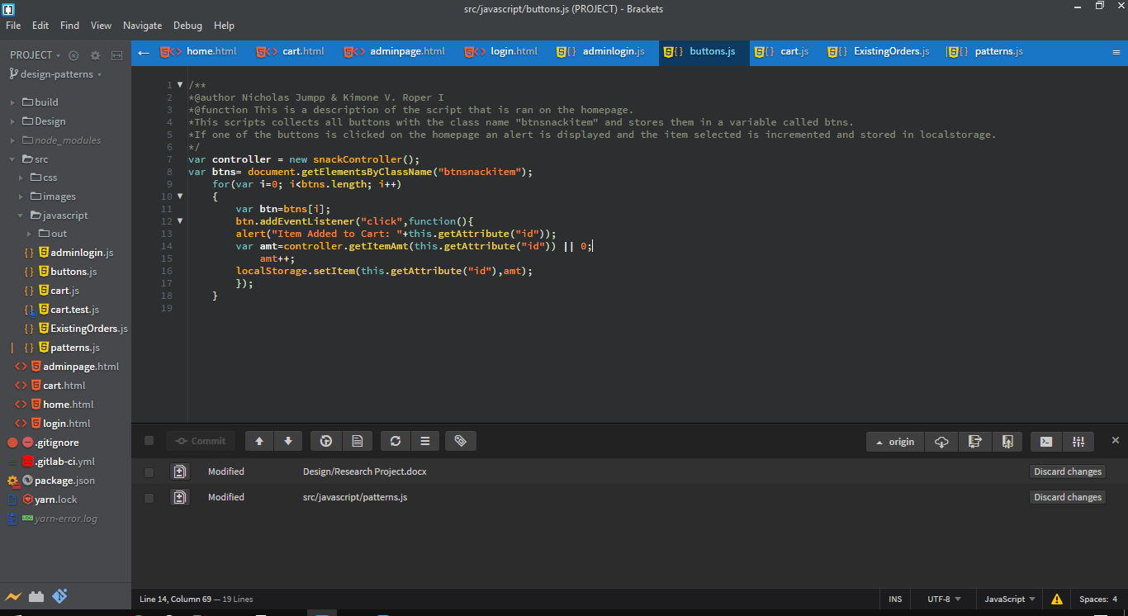

As seen in the screenshot above in the buttons.js file an instance of the snackController is created which is used to communicate between the model(localStorage) and the view which is the even listener that is is seen here.

Repository Pattern

The Repository Pattern restricts us to work directly with the data in the application and creates new layers for database operations, business logic, and the application’s UI.



Sometimes are controllers are too tightly coupled to a particular implementation. Abstraction can be used to reduce this coupling. In the screenshot above shows an example of the repository pattern instead of strictly declaring it to use localStorage it takes a parameter dbType that species what means of storage is preferred to be used during run-time.

Singleton Pattern

“The singleton pattern is a design pattern that restricts the instantiation of a class to one object” (Singleton, 2018).

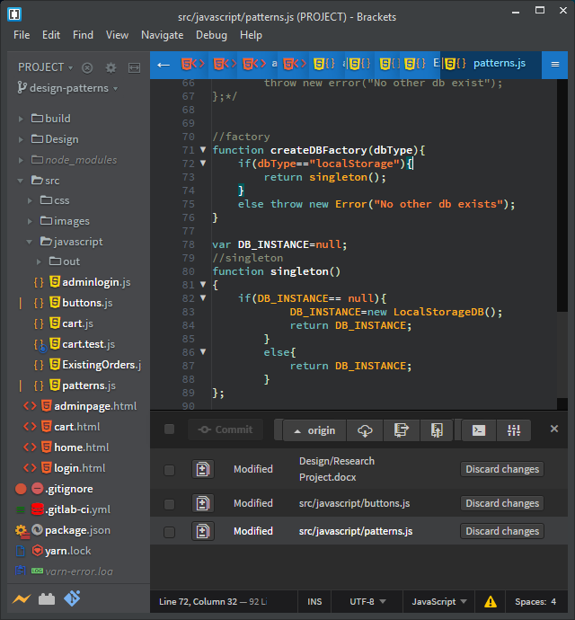

The screenshot above demonstrates the singleton pattern in which only instance of the object/class should be present. How this is accomplished is that a variable called DB_ISNTANCE is created and set to null from that the singleton() function in pattern.js checks if an instance has already been created. If an instance has not been created an instance is created of the LocalStorageDB and returned to be used by the function that request to access the model. If an instance has already been created that it simply just returns the instance that was made previously.

Factory Pattern

“A Factory Pattern says that just define an interface or abstract class for creating an object but let the sub-classes decide which class to instantiate” (JavaTPoint, n.d.).

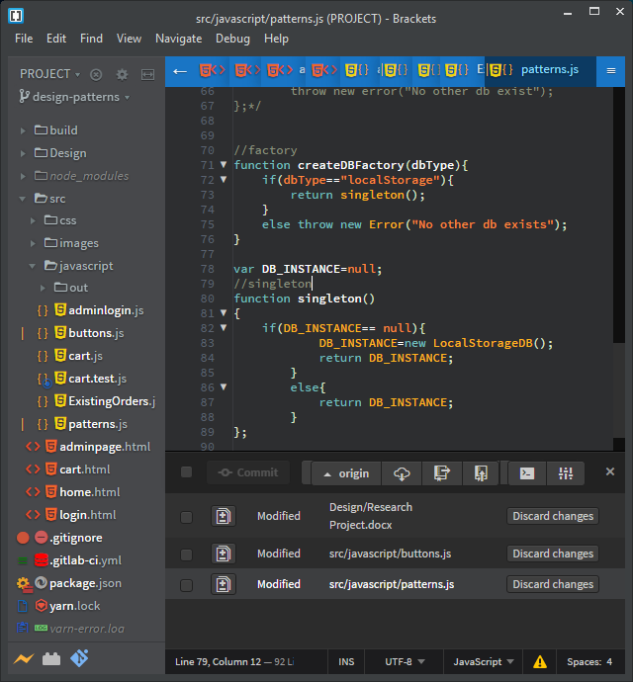

The screenshot above demonstrates the factory pattern as to which it checks which storage type is being requested as seen with the parameter dbType. An if statement then checks as to which method of storage is being requested for example checking to see if the localStorage database is being requested and if true then it calls the singleton to get an instance of the localStorage and to return it to the snackController() function.

**References**

Barber, A. P. (2015, August 06). SOLID Principles - Five Principles of Object-Oriented Programming and Design. Retrieved from <https://alanbarber.com/post/solid-principles-five-principles-of-objectoriented-pro> gramming-and-design/

JavaTPoint. (n.d.). Factory Method Design Pattern - Javatpoint. Retrieved from https://www.javatpoint.com/factory-method-design-pattern

Nnamdi, C. (2018, October 09). SOLID Principles every Developer Should Know. Retrieved from <https://blog.bitsrc.io/solid-principles-every-developer-should-know-b3bfa96bb68> 8

Singleton Design Pattern | Implementation. (2018, September 10). Retrieved from https://www.geeksforgeeks.org/singleton-design-pattern/

Tutorialspoint.com. (n.d.). Design Patterns MVC Pattern. Retrieved from https://www.tutorialspoint.com/design_pattern/mvc_pattern.htm